SeaLife Tech advice
For all SeaLife International Distributors/Service Centers

Date: September 16, 2009

Subject: DC1000 Lock up

Applies to: All DC1000 cameras

Symptoms: After powering on camera and taking a picture, the camera locks up. The camera-ready LED will continue blinking green and red for about 10 seconds and then stays green. When you starting pushing buttons, the LCD turns off. You have to remove the battery to power off the camera.

Cause: The lock-up is caused by MAC Operating System saves hidden files on to the SD memory card. See picture below showing the hidden files (i.e. “.Trashes”, “._.Trashes” and “.DS_Store”). You will not see these files on your computer unless you select “Show Hidden Files” located in the Windows Control Panel → Folder Options.

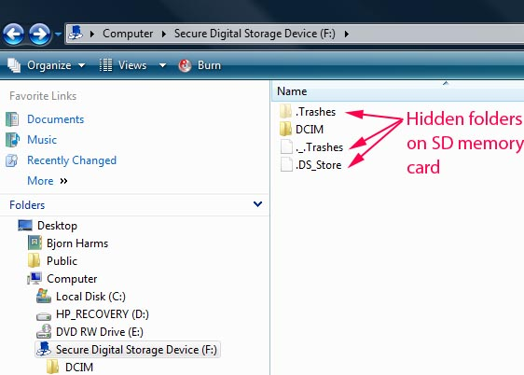

Solution: SeaLife is working on a firmware solution to prevent this lock-up issue. Until a new firmware is released, please advise MAC users to FORMAT the memory card after the camera or card has been connected to a MAC computer. Refer to page 18 of the DC1000 instruction manual for instruction on how to format the memory card.

Warranty: Not applicable
Repair: See Solution
Distribution: For release to the general public, dealers and worldwide service centers.

